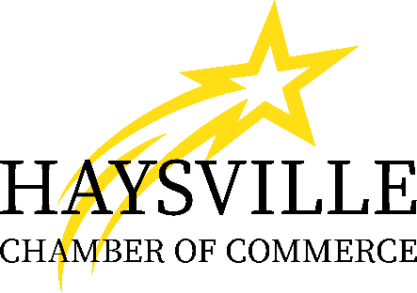
Haysville Chamber of Commerce
210 South Main
Haysville, Kansas 67060
DeAnn Konkel, Director
316-529-2461 ~ Voice or Text
haysvillechamber.com

2026 Haysville Chamber’s Annual Scholarship Golf Tournament
Sponsorship Opportunities

Title Sponsor - $3,000 (Sold)
- Shared naming rights to the 2026 Scholarship Awards
- Logo on all promotional materials and signage
- Up to 3 complimentary foursome teams
- Recognition during the award ceremony and lunch
- 2 Free drink tickets (beer or soda) per player
- 1 EXTRA Mulligan per player

Platinum Sponsor - $1,500
- Logo on event banner and registration signage
- Up to 2 complimentary foursome teams
- Recognition in the event program and on social media
- 1 Free drink ticket (beer or soda) per player

Gold Sponsor - $600
- Logo on event banner
- 1 complimentary foursome team
- Name listed in the event program and on social media

Player Cart Sponsor - $450 (2 Available)
- Company logo displayed on each golf cart
- Social Media Recognition

Beverage & Snack Cart Sponsor - $400 (2 Available)
- Company logo displayed on beverage cart
- Recognition in program and at award ceremony

First Place Prize Sponsors - $500 (Need 2)
- Logo on Prize Banner
- Recognition during award ceremony and on social media

Hole-in-One Sponsor - $300
- Logo on prize banner & designated hole signage
- Recognition during award ceremony and on social media

Longest Drive - $250 (Need 2 - Male & Female)
- Logo on prize banner & designated hole signage
- Recognition during award ceremony and on social media

Longest Putt - $250
- Logo on prize banner & designated hole signage
- Recognition during award ceremony and on social media

Closest to the Pin - $250
- Logo on prize banner & designated hole signage
- Recognition during award ceremony and on social media

Hole Sponsorship - $200 (Need 18)
- Signage on assigned hole with business name and logo
- Option to host a table or tent at your assigned hole with games, prizes, giveaways, etc. of your choosing
- Social Media Recognition

Food Sponsorship (Breakfast, Lunch & Snacks) - $700 (2 Sponsorships for Lunch, 3 Sponsorships would allow for breakfast)
- Logo on Breakfast & Lunch Signage
- Verbal thank you during announcements
- Recognition in the program and on social media

Raffle Items
- We are looking for donations to be used for silent auction/raffle items. If you have gift cards/certificates or gifts baskets that you are willing to donate, please contact DeAnn at haysvillechamber@gmail.com

All Sponsorship Levels
- Option to include promotional swag items in player bags

